**OOPJ Module Exam PRN** - **220940320077**

- - - - - - - - - - - - - - - - - - - - - - - - - - - - - -- - - - - - - - - - - - - - - - - - - - - - - - - - - - - - - - - - - - - - - - - - - - - - -

Question 1)

You have been given a String S consisting of uppercase and lowercase English alphabets. You need to change the case of each alphabet in this String. That is, all the uppercase letters should be converted to lowercase and all the lowercase letters should be converted to uppercase. You need to then print the resultant String to output.

Solution:

import java.util.Scanner;

class StringDemo

{

public static void main(String[] args)

{

Scanner sc = new Scanner(System.in);

System.out.println("Enter any String : ");

String str = sc.nextLine();

String tgl = "";

for (int i=0; i < str.length() ; i++)

{

if(Character.isUpperCase(str.charAt(i)))

tgl = tgl+Character.toLowerCase(str.charAt(i));

else

tgl = tgl+Character.toUpperCase(str.charAt(i));

}

System.out.println("Input : "+str);

System.out.println("Output : "+tgl);

}

}

Output:

C:\Users\HP\Desktop\OOPJ EXAM>java StringDemo

Enter any String :

abcdE

Input : abcdE

Output : ABCDe

C:\Users\HP\Desktop\OOPJ EXAM>java StringDemo

Enter any String :

I love my India

Input : I love my India

Output : i LOVE MY iNDIA

C:\Users\HP\Desktop\OOPJ EXAM>java StringDemo

Enter any String :

cdac@Mumbai

Input : cdac@Mumbai

Output : CDAC@mUMBAI

CMD Snapshot:

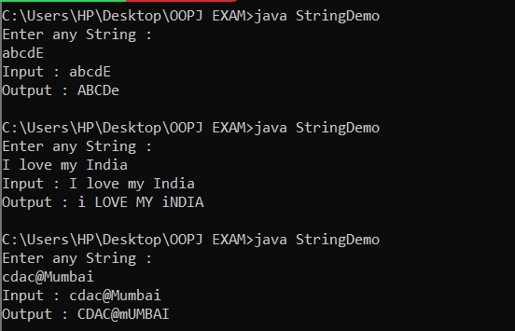

Test Cases:

Test Case 1 ):

C:\Users\HP\Desktop\OOPJ EXAM>java StringDemo

Enter any String :

abcdE

Input : abcdE

Output : ABCDe

Test Case 2 ):

C:\Users\HP\Desktop\OOPJ EXAM>java StringDemo

Enter any String :

I love my India

Input : I love my India

Output : i LOVE MY iNDIA

Test Case 3 ):

C:\Users\HP\Desktop\OOPJ EXAM>java StringDemo

Enter any String :

cdac@Mumbai

Input : cdac@Mumbai

Output : CDAC@mUMBAI

**Question** **2)**

Write a Java Program for following Exception Handlers thrown by the code with given messages:

**Division by zero: Print "Invalid division".**

**String parsed to a numeric variable: Print "Format mismatch".**

**Accessing an invalid index in string: Print "Index is invalid".**

**Accessing an invalid index in array: Print "Array index is invalid"**

**Solution:**

**import java.util.*;**

class MyException extends Exception

{

}

class ExceptionHandling

{

public static void main(String args[])

{

try

{}

catch(ArrayIndexOutOfBoundsException e)

{

System.out.println("Array index is invalid");

}

catch(ArithmenticException e)

{

System.out.println("Invalid division");

}

catch(NumberFormatException e)

{

System.out.println("Format mismatch");

}

catch(StringIndexOutOfBoundsException e)

{

System.out.println("Index is invalid");

}

finally

{

System.out.println("Exception Handling Completed");

}

}

}

**Output:**

**CMD Snapshot:**

**Test Cases:**

**Test Case** 1):

**Question** **3)**  Write a Java Program to implement the given inheritance with Shape is super class for Rectangle and Triangle class with getArea() to calculate the area of rectangle and triangle.

**Solution:**

class Shape

{

double height;

double width;

void setValues(double height, double width)

{

this.height= height;

this.width=width;

}

double getHeight()

{

return height;

}

double getWidth()

{

return width;

}

}

class Rectangle extends Shape

{

double getArea()

{

return getHeight()*getWidth();

}

}

class Triangle extends Shape

{

double getArea()

{

return (getHeight()*getWidth())/2;

}

}

class ShapeDemo

{

public static void main(String args[])

{

Rectangle r = new Rectangle();

Triangle t = new Triangle();

r.setValues(5,10);

t.setValues(5,10);

double areaOfRectangle = r.getArea();

System.out.println("Area of the rectangle : "+areaOfRectangle);

double areaOfTriangle = t.getArea();

System.out.println("Area of the triangle: "+areaOfTriangle);

}

}

**Output:**

C:\Users\HP\Desktop\OOPJ EXAM>javac ShapeDemo.java

C:\Users\HP\Desktop\OOPJ EXAM>java ShapeDemo

Area of the rectangle : 50.0

Area of the triangle : 25.0

**CMD Snapshot:**

